R.VINOD REDDY, Advocate

Standing Counsel for TSTRANSCO/TSSPDCL

H.No.8-2-684/4/31, Plot No.26, Anand Banjara,

Road No.12, Banjara Hills, Hyderabad – 500034

Ph: 040-23304342
9849041514

Advance Receipt

Date: 06-07-2020

Received a sum of Rs.12000/- (Rupees Twelve thousand only) as per latest SP. O. O Js(IR & M) Ms. No. 24 dated 08-01-2018 from Senior Accounts Officer, Operations, Vikarabad, TSSPDCL towards filing Vacate Stay Petition and Counter Affidavit in WP. No 5822 of 2020 filed by M/s. Cement Corporation of India Ltd before Hon’ble High Court at Hyderabad.

1) Legal Fee : Rs. 5000 =00
2) Filling Expenses : Rs. 5000=00
3) Vacate Stay Petition : Rs. 2000=00

Total : Rs. 12000=00

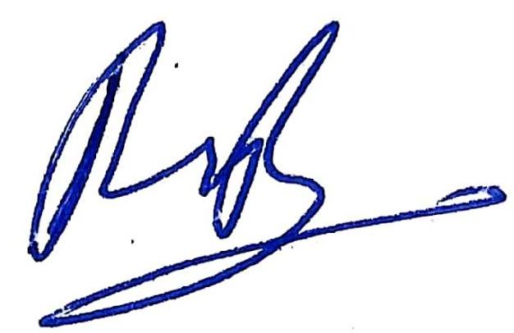
(R.Vinod Reddy)

